María Isamar Saldaña Gálvez Oswaldo García Cervantes
Continental Santa anita
26 de Noviembre de 2015
LIN - sCHEDULER
Practice 3



Title: | <LIN - Scheduler>  SW Component < 1.0 >

History
Issue status  (Index) | Maturity/Date  (draft/invalid/valid)  (26-Nov-2015) | Author  AEP I B&S | Check/Release  Department | Description
1.0 | Draft  26-Nov-15 | Maria Isamar Saldaña G. | Oswaldo Garcia Cervantes | Creation of the document
Issue status  (Index) | Maturity/Date  (draft/invalid/valid)  (27-nov-2015) | Author  AEP I B&S | Check/Release  Department | Description
1.0 | Draft  26-Nov-15 | Oswaldo García Cervantes | Maria Isamar Saldaña G. | Changes of the document

Images

Image 1. MPC560 blocks diagram 8
Image 2. Bolero card 8

Tables

Table 1. Masters and slaves 4
Table 2. Messages of LIN 4
Table 3. Definitions 5
Table 4. Abbreviations 6
Table 5. References 6

Purposes

The main objective of this practice, is knowing how the LIN communication protocol, so as to send and receive data over the protocol.
We have a master, and this certain send messages with ID and calculated, our purpose is to program the development board bolero.
In the Table 1. Masters and slaves you can see when the master have 4 slaves for send messages.
In the Table 2. Messages of LIN you can see the all messages that send the master, we are team 2, and we only listen the messages for slave 2, the other messages they will be ignored.

Master node name | Slaves
MASTER |  | SLAVE1
 |  | SLAVE2
 |  | SLAVE3
 |  | SLAVE4

Table 1. Masters and slaves

Msg ID | Msg Name | Msg Data Len |  | Msg Publisher | Msg Subscribers | Msg Callback
CF | MASTER_CMD_ALL | 1 | MASTER |  | SLAVE1, SLAVE2, SLAVE3, SLAVE4 | auto
50 | MASTER_CMD_SLV1 | 1 | MASTER |  | SLAVE1 | auto
11 | MASTER_CMD_SLV2 | 1 | MASTER |  | SLAVE2 | auto
92 | MASTER_CMD_SLV3 | 1 | MASTER |  | SLAVE3 | auto
D3 | MASTER_CMD_SLV4 | 1 | MASTER |  | SLAVE4 | auto
20 | SLAVE1_RSP | 2 | SLAVE1 |  | MASTER | auto
61 | SLAVE2_RSP | 2 | SLAVE2 |  | MASTER | auto
E2 | SLAVE3_RSP | 2 | SLAVE3 |  | MASTER | auto
A3 | SLAVE4_RSP | 2 | SLAVE4 |  | MASTER | auto
F0 | SLAVE1_ID | 7 | SLAVE1 |  | MASTER | auto
B1 | SLAVE2_ID | 7 | SLAVE2 |  | MASTER | auto
32 | SLAVE3_ID | 7 | SLAVE3 |  | MASTER | auto
73 | SLAVE4_ID | 7 | SLAVE4 |  | MASTER | auto

Table 2. Messages of LIN

Definitions and abbreviations
In this part you can find this functions and words used for to development practice.

Definitions
In the Table 3. Definitions you can watch the functions used for this practice “Window lifter”.

Acronym | Definition
  master_cmdForAll
  master_cmdForSlave1
  master_cmdForSlave2
  master_cmdForSlave3
  master_cmdForSlave4
  slave1_LEDstat
  slave1_enabled
  slave1_supplier
  slave1_serial
  slave2_LEDstat
  slave2_enabled
  slave2_supplier
  slave2_serial
  slave3_LEDstat
  slave3_enabled
  slave3_supplier
  slave3_serial
  slave4_LEDstat
  slave4_enabled
  slave4_supplier
  slave4_serial
  Command for all nodes
  Command for node 1
  Command for node 2
  Command for node 3
  Command for node 4
  Return LED Status
  Return Node Status
  Return Team number
  Returns initials of members team
  Return LED Status
  Return Node Status
  Return Team number
  Returns initials of members team
  Return LED Status
  Return Node Status
  Return Team number
  Returns initials of members team
  Return LED Status
  Return Node Status
  Return Team number
  Returns initials of members team

Table 3. Definitions

Abbreviations
In the Table 4. Abbreviations you can watch the words used for this practice “Window lifter”.

Acronym | Definition
LED | Light – emitting diode is a two-lead semiconductor light source
CRT | Conversion timing register
GPIO | Input and output in the MCU
STM | Timer of MCU
Interruption | Interruption of MCU
IPM | Input period measurement

Table 4. Abbreviations

References
In the Table 5. References you can watch the words used for this practice “Window lifter”.

N° | Document name
1 | Traceability Matrix Template
2 | Window-lifter-requirements-Classification-
3 | Bolero_1.5M_FSL_RM_Rev7_2.pdf
4 | Test Plan
5 | variables_naming_rule
6 | http://www.freescale.com/products/power-architecture-processors/mpc5xxx-5xxx-32-bit-mcus/mpc56xx-mcus/ultra-reliable-mpc56xb-mcu-for-automotive-industrial-general-purpose:MPC560xB#pspFeatures
7 | SW_C_Code_Review_Template
8 | Scheduler - Reference manual

Table 5. References

Realization constraints and targets

The project will be implemented with Bolero architecture, therefore is limited to the characteristics and their components of this board.

Bolero card characteristics:

- MPC5606B MCU in a 144LQFP package.
- On-board JTAG connection via open source OSBDM circuit using the MPC9S08JM MCU
- MCZ3390S5EK system basis chip with advanced power management and integrated CAN transceiver.
- CAN and LIN interface.
- Analog interface with potentiometer.
- High-efficiency LEDs.
- SCI serial communication interface.
- Operating Frequency (Max): 64 MHz.
- Total DMA Channels 16.
- Internal Flash (KB): 512
- GPIOs: 149.
- EEPROM: 64 KB DataFlash®
- RAM: Up to 96 KB
- Timer: 16 bits up to 64 channels

In the Image 1. MPC560 blocks diagram, you can see the internal card and its different ports.
In the Image 2. Bolero card in which you can see the physical card or MCU used for this practice.

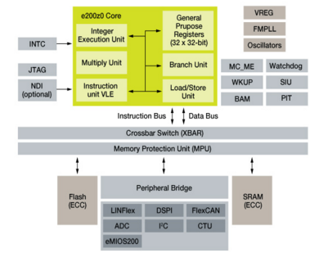

Image 1. MPC560 blocks diagram

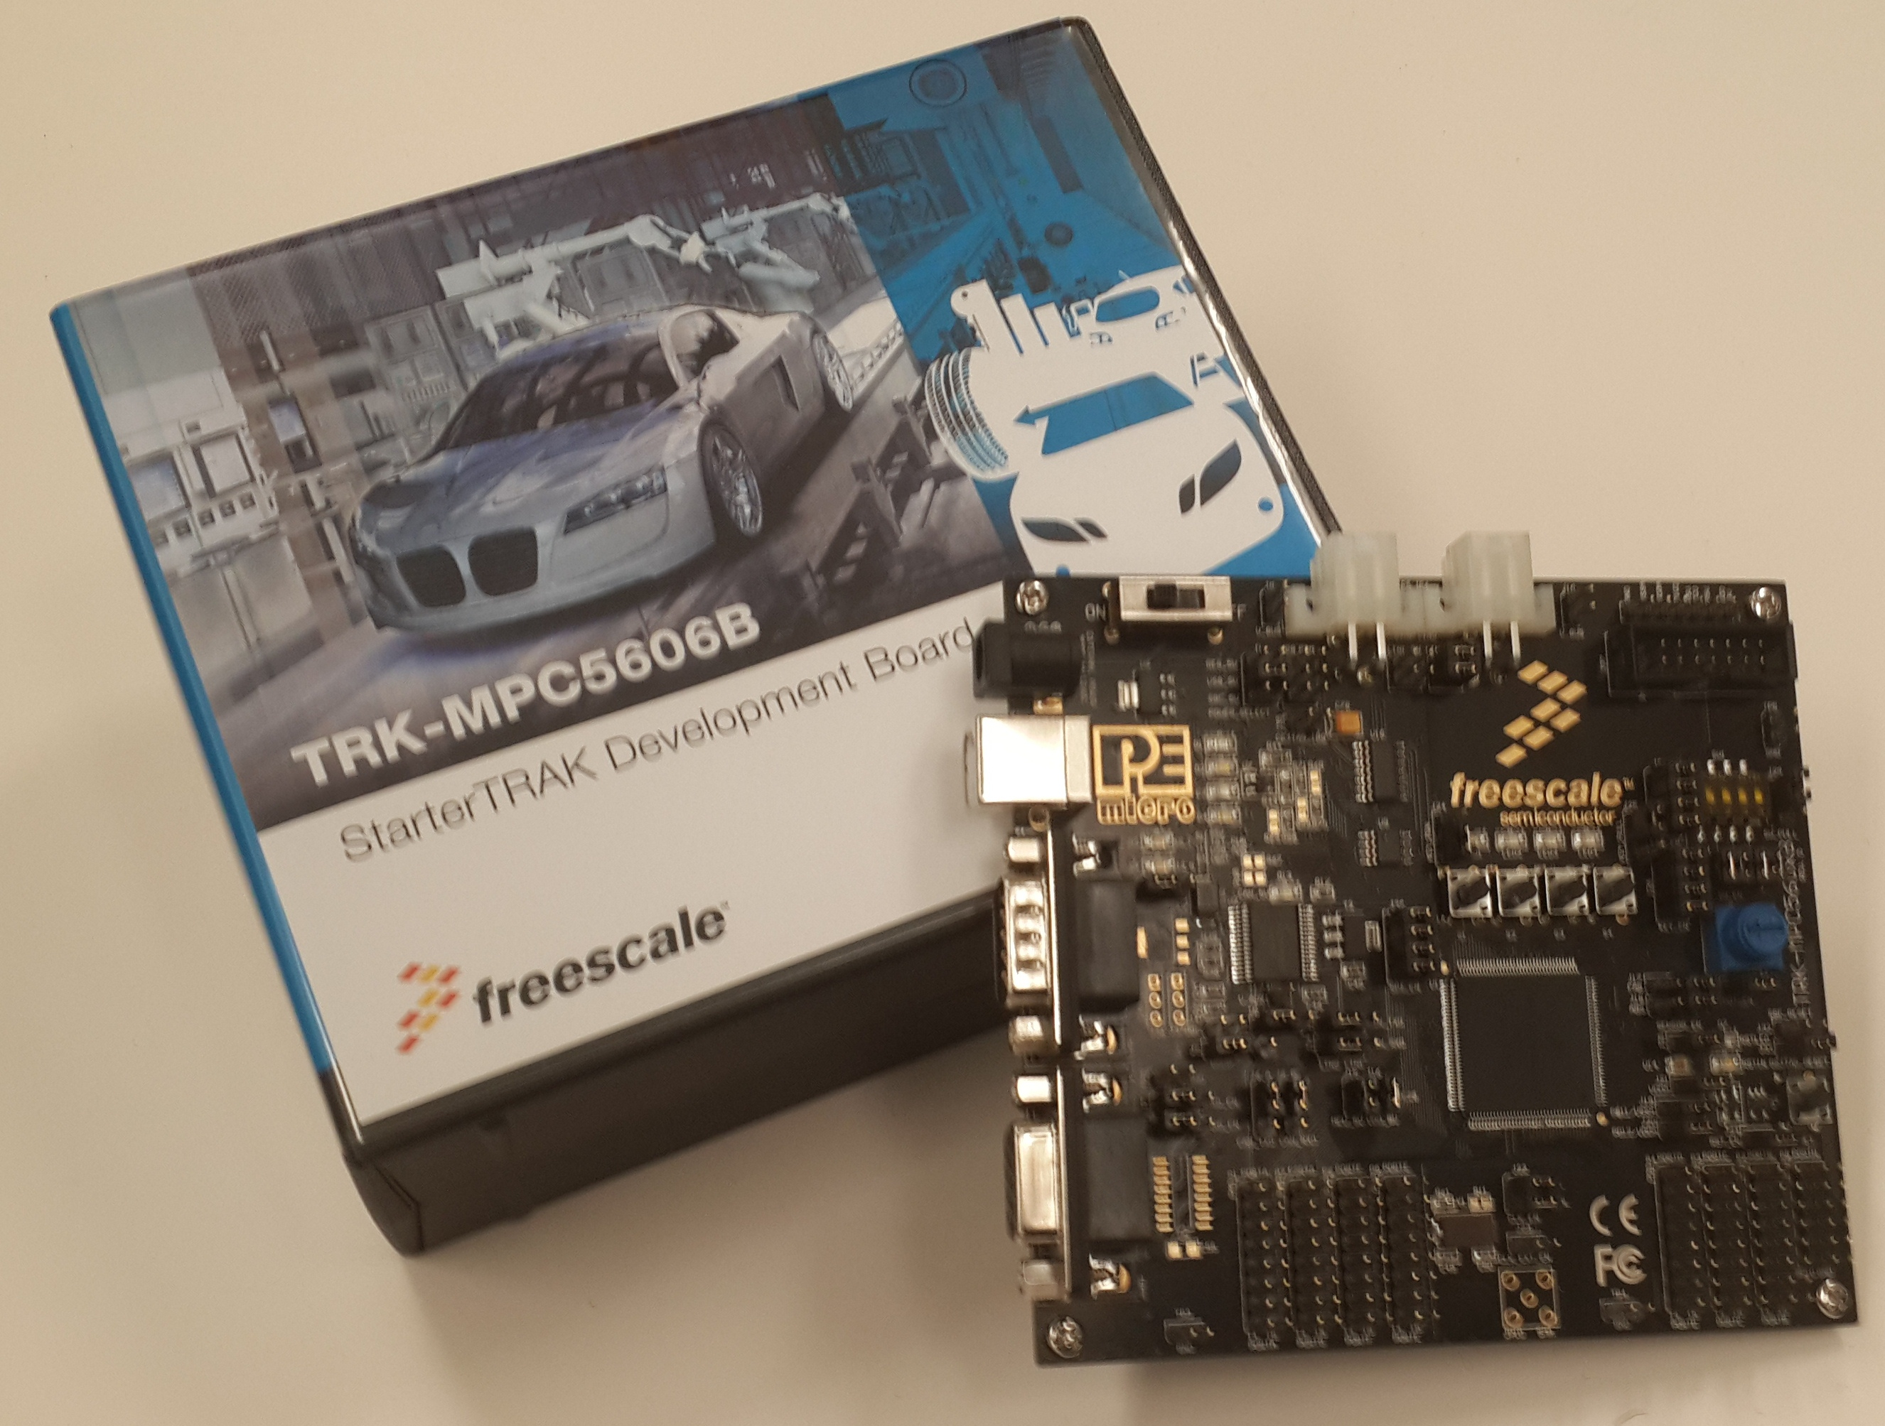

Image 2. Bolero card
Purpose
This document has been created as a demonstration to the students of UdeG to how to create the detailed design from requirements.

Definitions and abbreviations
Definitions
Special Byte | Special byte received to change the baudrate 55h

Abbreviations
Only SW Component specific abbreviations.
References
N° | Document name | Reference
1 | SW Architecture description

Realization constraints and targets

An overview of which are the goals that must be achieved with this functionalities.

SW Conceptual design
To make a conceptual design identify the product functions and the programs parts needed to produce them.
- Identifie all relevant parts in a system or sub-system.
- Define which parts are inside & outside the system boundary
- Define de interfaces between these parts, but also interfaces with neighboring systems and environment.

SW Component internal breakdown
For complex SW Components, the designer may define SW Subcomponents. Please consider also the work step "Deal with complexity" provided by the method for Detailed SW Design.
Note: SW Subcomponents are synonymous with the previous used term "Module"
Mapping to the file structure:
- Non complex SW Components should be represented by one object file.
- For complex SW Components each SW Subcomponent should be represented by one object file.
<Subcomponent decomposition if applicable>

Functional Decomposition
Overview of functions and their dependencies shown by a Static Function Tree
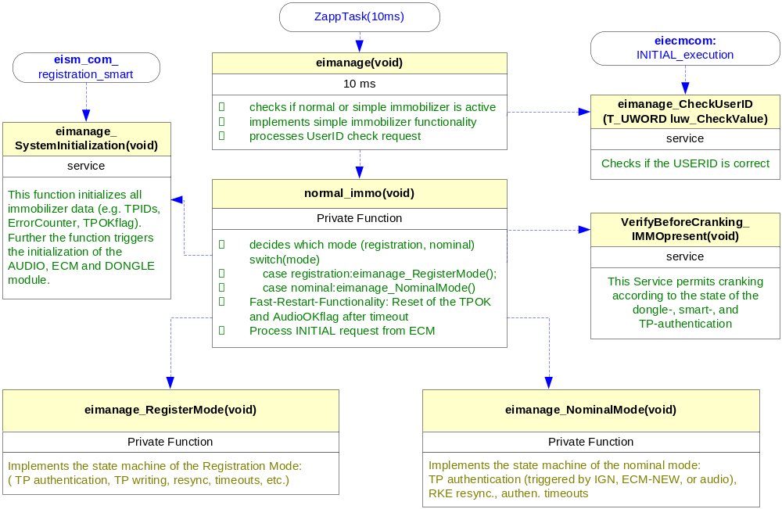
Function Description and Dynamic Behavior
Provide detailed static and dynamic description of all functions of the SW Component.
Functions which are defined in other SW Components shall only be referenced in the external interface description!
The signature description shall be done inside the function header in the source code.
For each function, the following section should be copied

Function <Type> <function name> (type par 1, .., type par n)

Description | Brief description of the function behavior and useful remarks
Parameter 1  <input| output| inout> | Give an explanation if the parameter shall be checked by the user, or if a check is implemented in the function here
Parameter 2..n
Return Value
Precondition | e.g. Function can only be called in a certain state, SW component is initialized  Relation between input parameters where applicable (Input for Module Test)
Post condition | e.g. specific State change e.g. car is locked, EEPROM Values written,  Relation between output parameters where applicable
Error Conditions

Dynamic Behavior
State Chart¹, Flow Chart¹
¹ Preferred
In this document, the dynamic behavior shall be designed on an abstract level showing the principle workflow of a function. Do not show the detailed implementation to ensure that the design description can be maintained with a reasonable effort. The target is not to show the complete detailed implementation 1:1.
The detailed design shall reflect in detail what a function is doing from a black box view. The internal details are useful on an abstract, but not very detailed level.
If the function is not complex a short textual description might be sufficient and a graphical description is not needed.
Symbol and function names shall be self explaining.
The link to the implementation may be provided by using the same names as in the design or by a comment showing the full name followed by the declaration showing the implementation.

Function <Type> <function name> (type par 1, .., type par n)
Description | Brief description of the function behavior and useful remarks
Parameter 1
<input| output| inout>
Parameter 2..n
Return Value
Precondition | e.g. Function can only be called in a certain state, SW component is initialized  Relation between input parameters where applicable (Input for Module Test)
Post condition | e.g. specific State change e.g. car is locked, EEPROM Values written,  Relation between output parameters where applicable
Error Conditions

Dynamic Behavior
State Chart¹, Flow Chart¹, Nassi Shneiderman
¹ Preferred
In this document, the dynamic behavior shall be designed on an abstract level showing the principle workflow of a function. Do not show the detailed implementation to ensure that the design description can be maintained with a reasonable effort. The target is not to show the complete detailed implementation 1:1.
The detailed design shall reflect in detail what a function is doing from a black box view. The internal details are useful on an abstract, but not on a very detailed level.
Symbol and function names shall be self explanatory.
The link to the implementation may be provided by using the same name as in the design or by a comment showing the full name followed by the declaration showing the implementation.

